# Material Value Sources:

For some basic materials and as a data template for GPT-4

http://www.barradeau.com/nicoptere/dump/materials.html

## ChatGPT – GPT-4

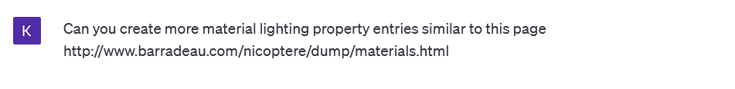

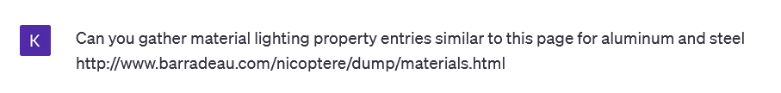

# Post and arm:

Material intended to be analogous to aluminum:

Base texture is aluminum so the ambient values remained the way that they came with the raw textures

The approximate values generated with the help of ChatGPT using the prompt:

